Arc
# Source: AI Source: Provided by: [Data Path: Persons Table -> ID Column: 1, Name_En Column: Motasem Essam] -> From: [ChatGPT] on [7/25/2026]
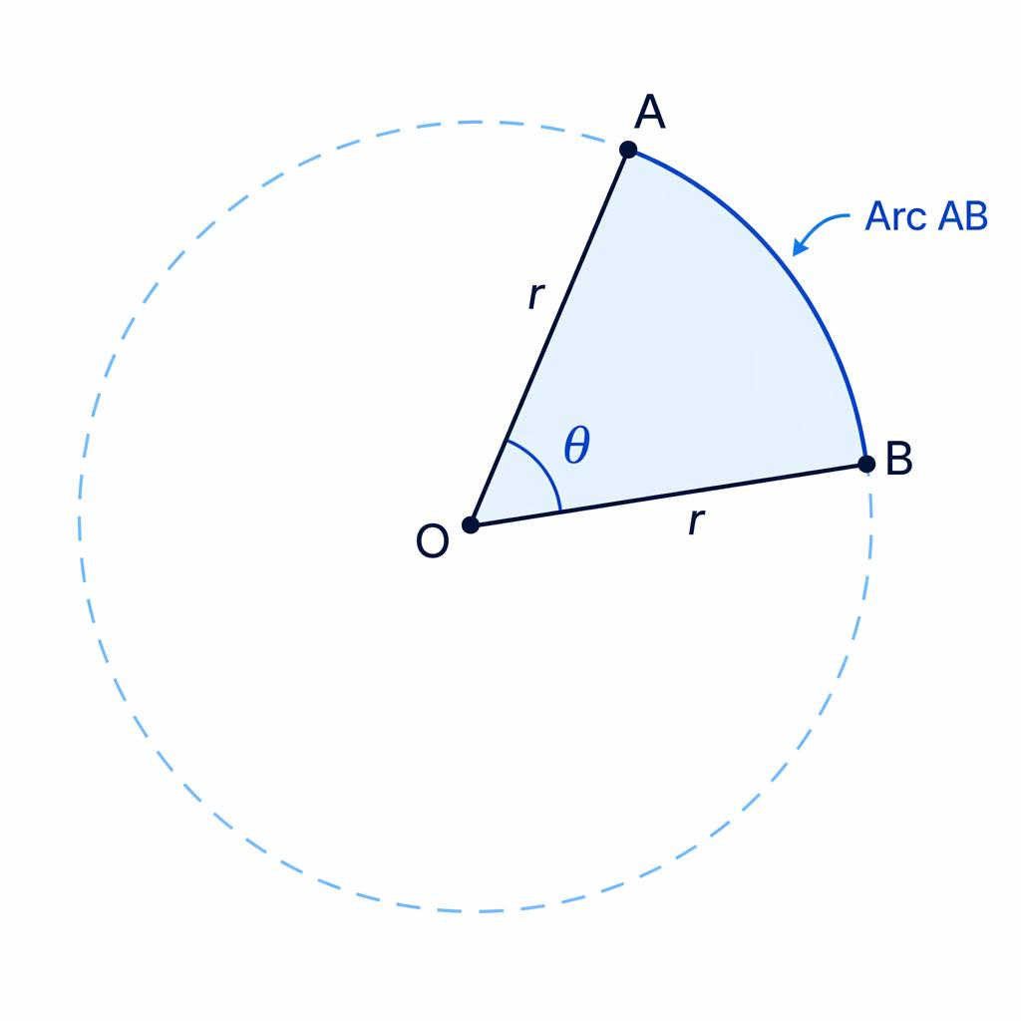
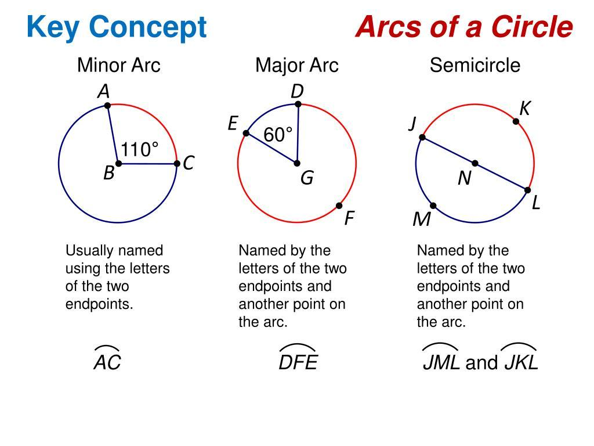
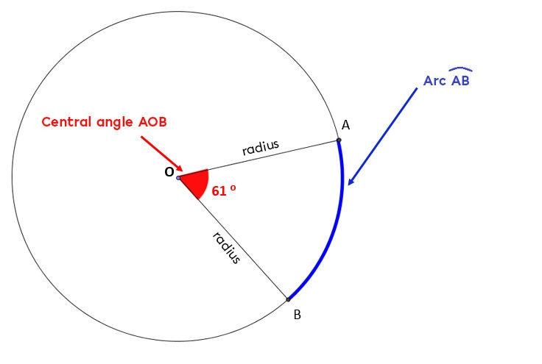
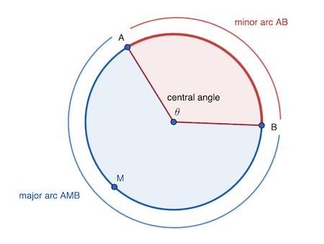
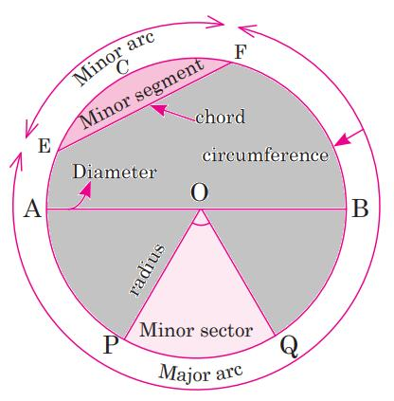
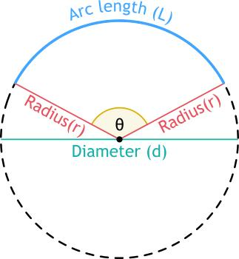

Definition
# Source: AI Source: Provided by: [Data Path: Persons Table -> ID Column: 1, Name_En Column: Motasem Essam] -> From: [ChatGPT] on [7/25/2026]
An arc is a continuous portion of the circumference of a circle between two points on the circle.
If $A$and $B$are points on a circle, the curved part of the circumference between them is an arc, written as:
$$\hat{AB}$$
Unlike a chord, which is a straight line segment, an arc follows the curved boundary of the circle.

Fundamental Elements
# Source: AI Source: Provided by: [Data Path: Persons Table -> ID Column: 1, Name_En Column: Motasem Essam] -> From: [ChatGPT] on [7/25/2026]
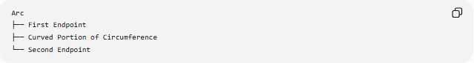
Arc
├── First Endpoint
├── Curved Portion of Circumference
└── Second Endpoint
The two endpoints lie on the circumference.
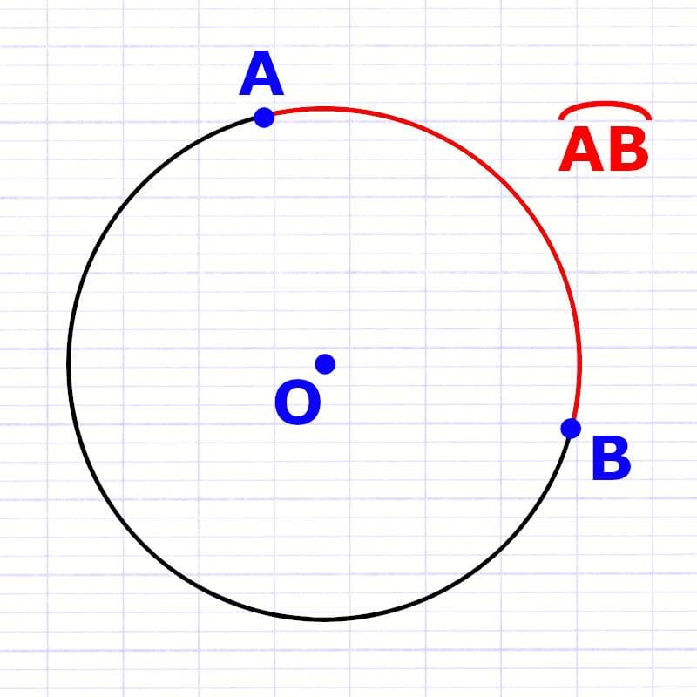
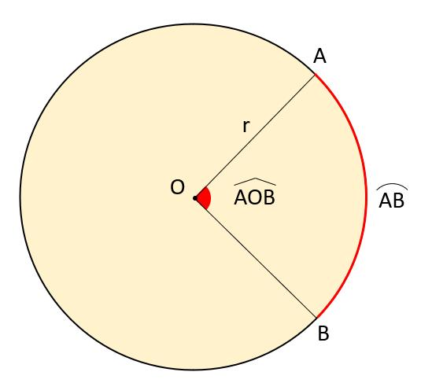
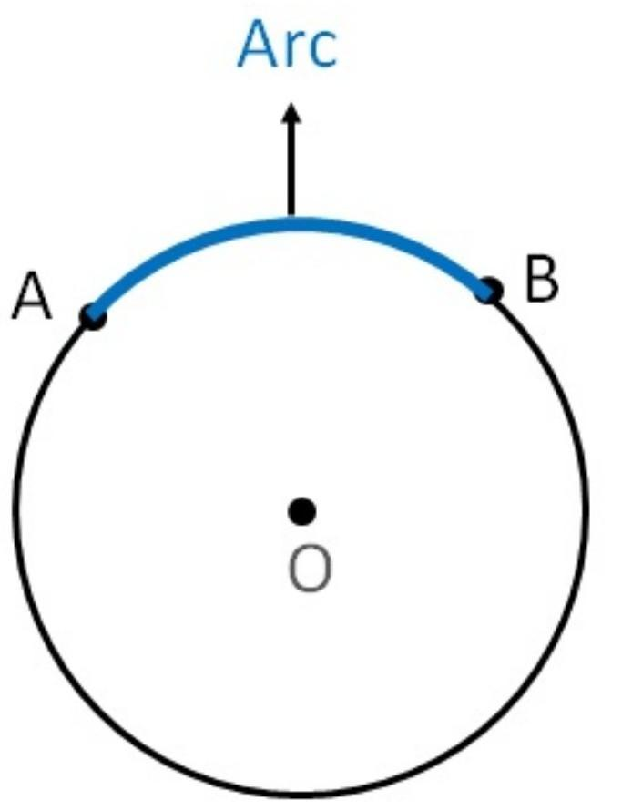
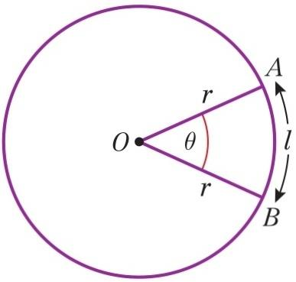

Types of Arcs
# Source: AI Source: Provided by: [Data Path: Persons Table -> ID Column: 1, Name_En Column: Motasem Essam] -> From: [ChatGPT] on [7/25/2026]
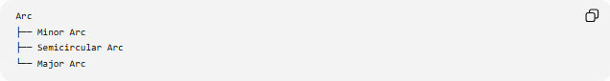
Arc
├── Minor Arc
├── Semicircular Arc
└── Major Arc

1. Minor Arc
# Source: AI Source: Provided by: [Data Path: Persons Table -> ID Column: 1, Name_En Column: Motasem Essam] -> From: [ChatGPT] on [7/25/2026]
A minor arc measures less than ${180}^{∘}$.
$$\boxed{m\left(\hat{AB}\right)<{180}^{∘}}$$
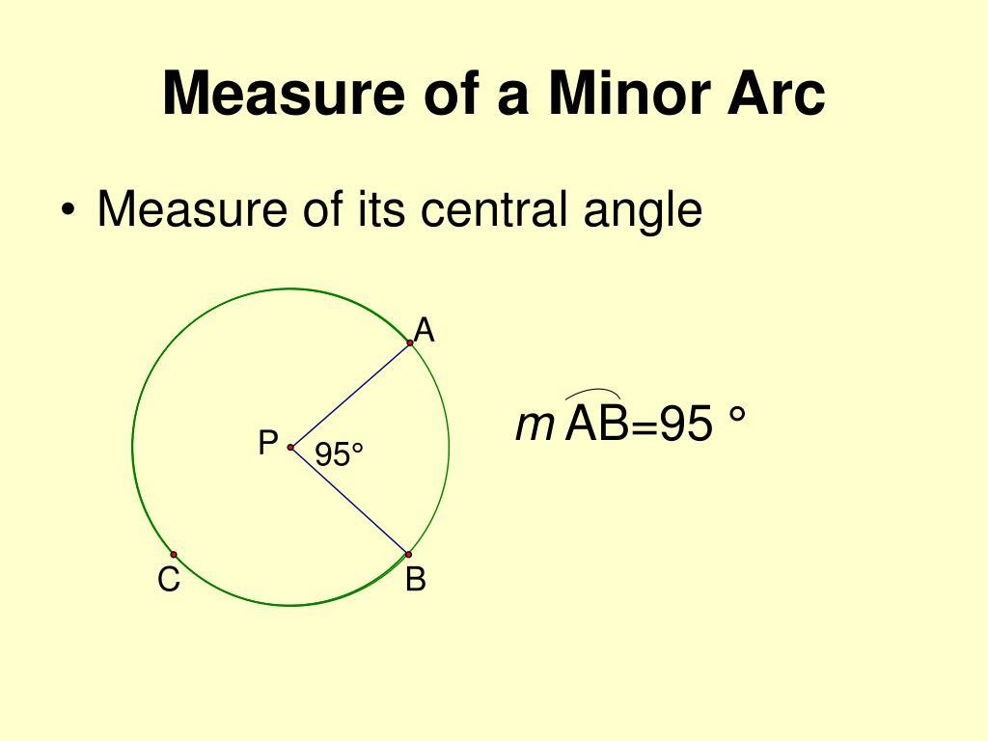
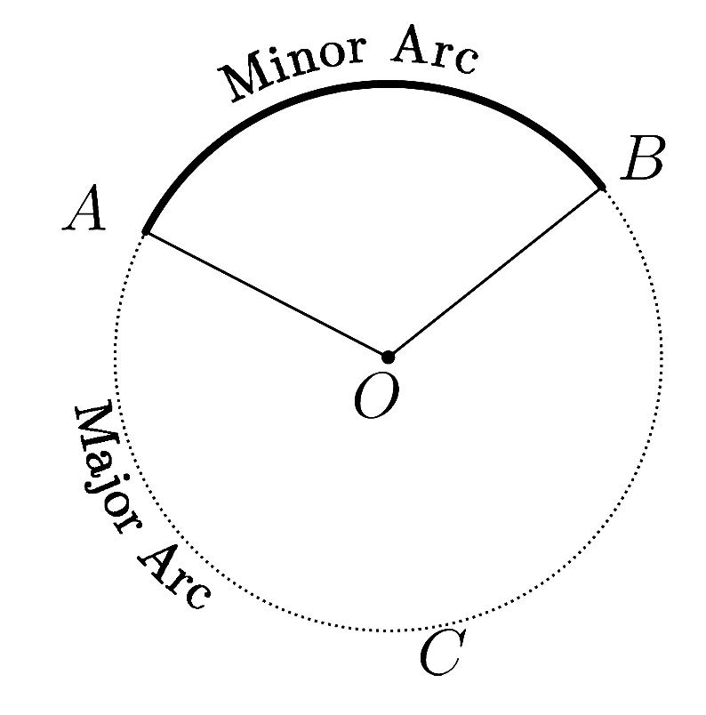
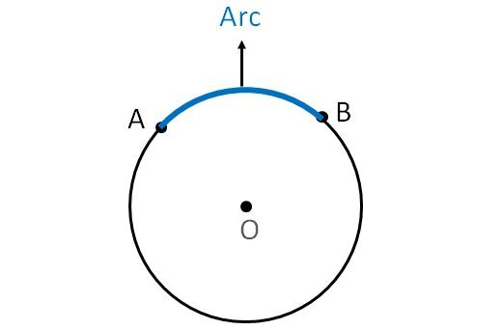
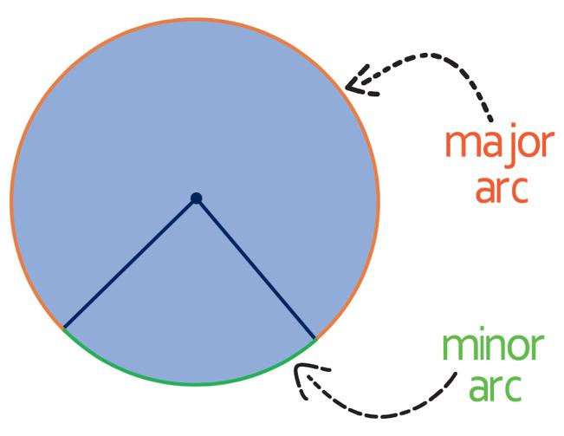

2. Semicircular Arc
# Source: AI Source: Provided by: [Data Path: Persons Table -> ID Column: 1, Name_En Column: Motasem Essam] -> From: [ChatGPT] on [7/25/2026]
A semicircular arc measures exactly ${180}^{∘}$.
$$\boxed{m\left(\hat{AB}\right)={180}^{∘}}$$
It is determined by a diameter.
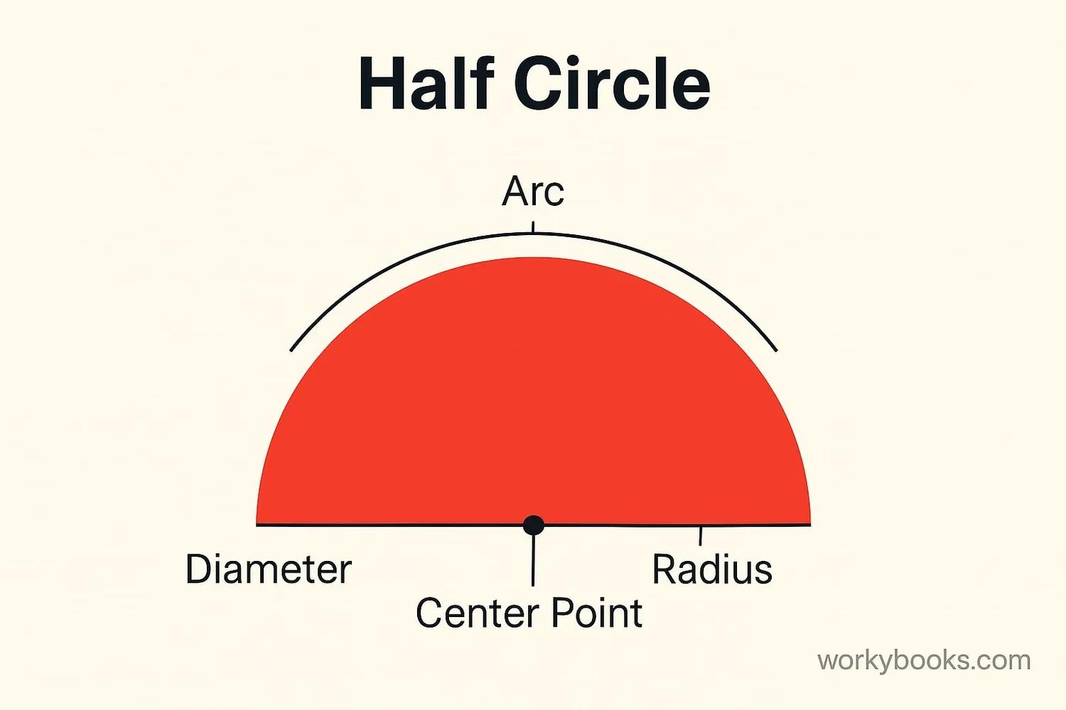
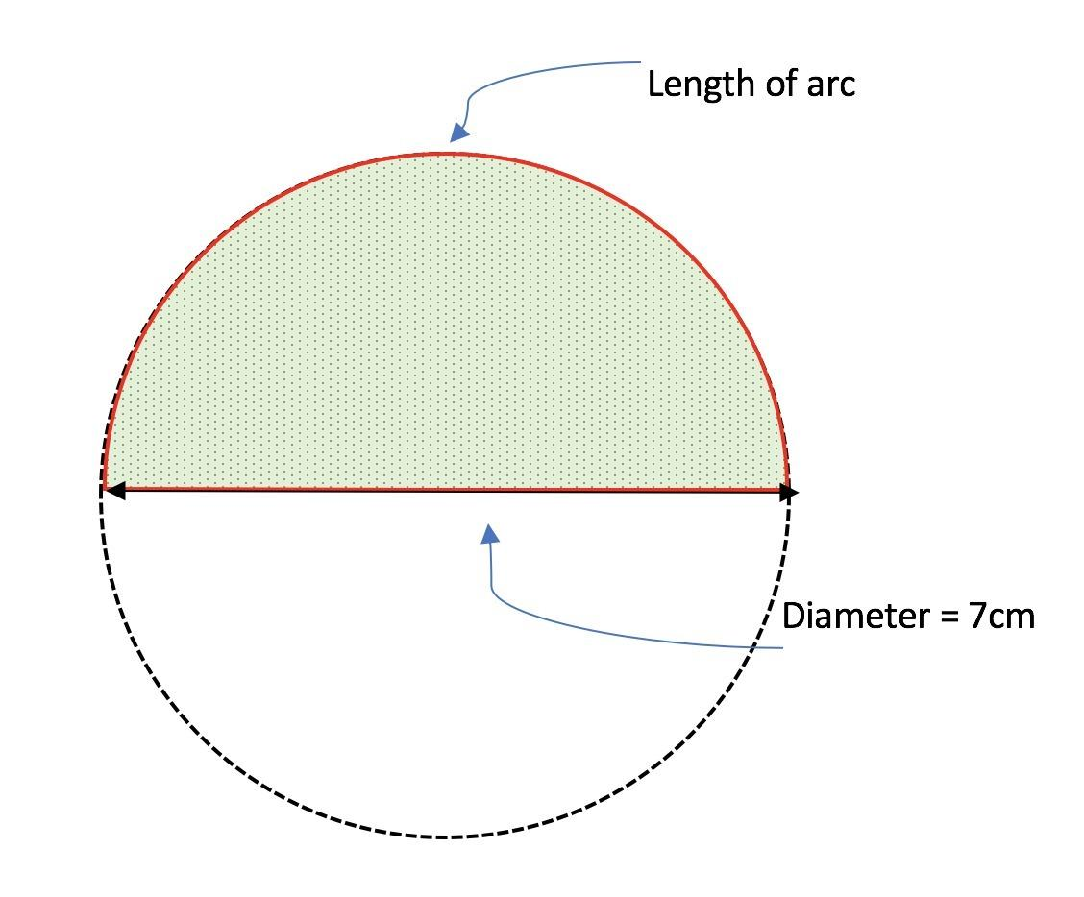
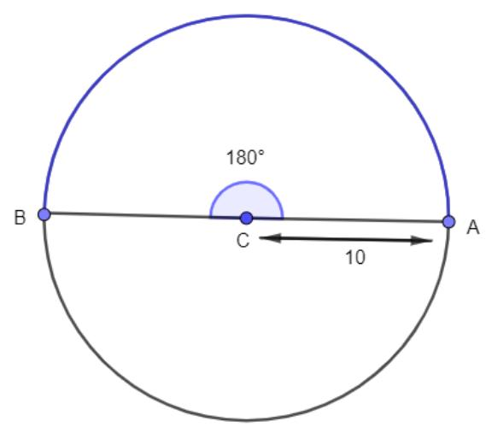
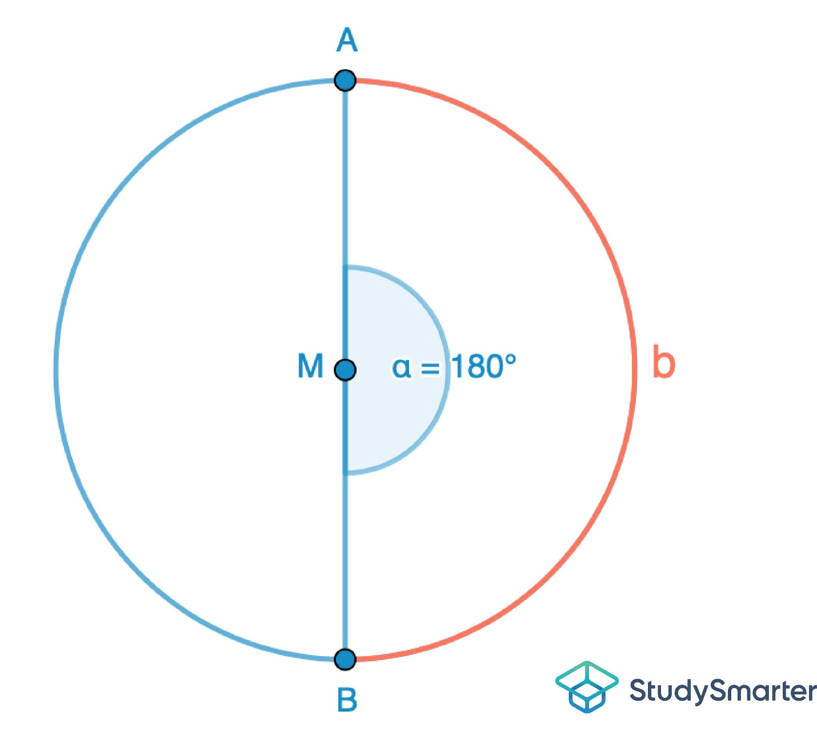
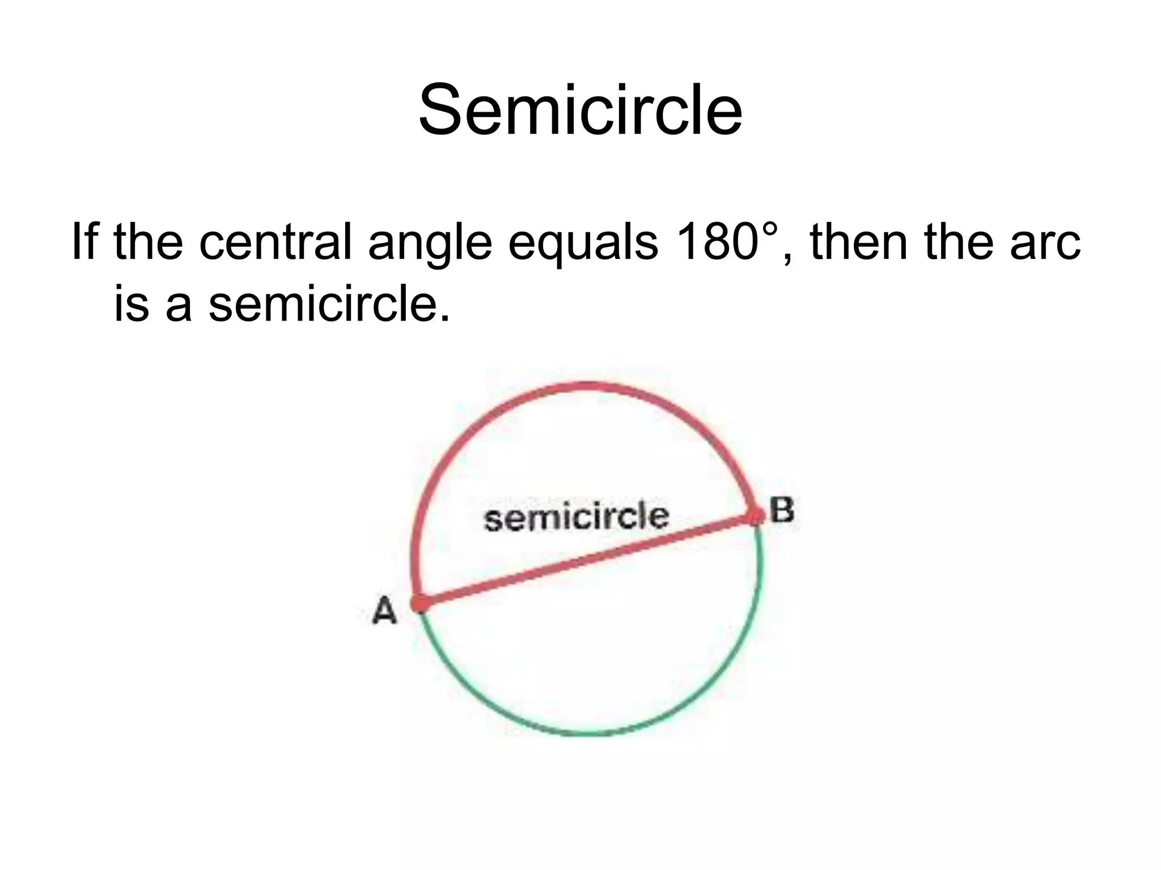

3. Major Arc
# Source: AI Source: Provided by: [Data Path: Persons Table -> ID Column: 1, Name_En Column: Motasem Essam] -> From: [ChatGPT] on [7/25/2026]
A major arc measures more than ${180}^{∘}$.
$$\boxed{m\left(\hat{AB}\right)>{180}^{∘}}$$
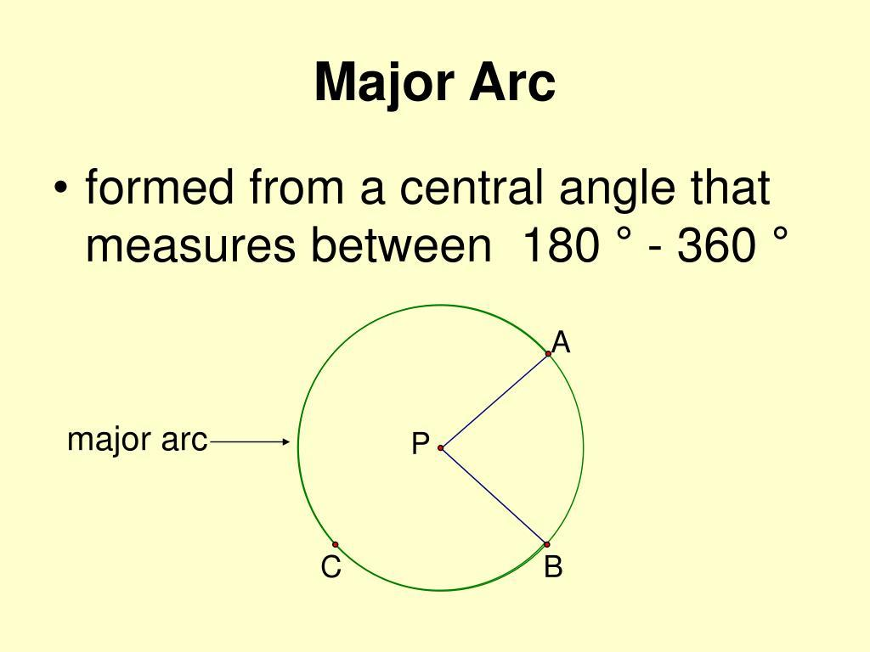
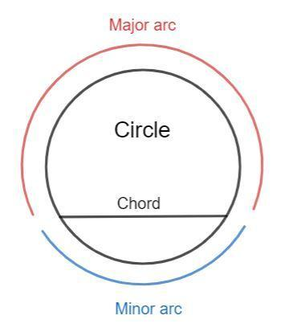
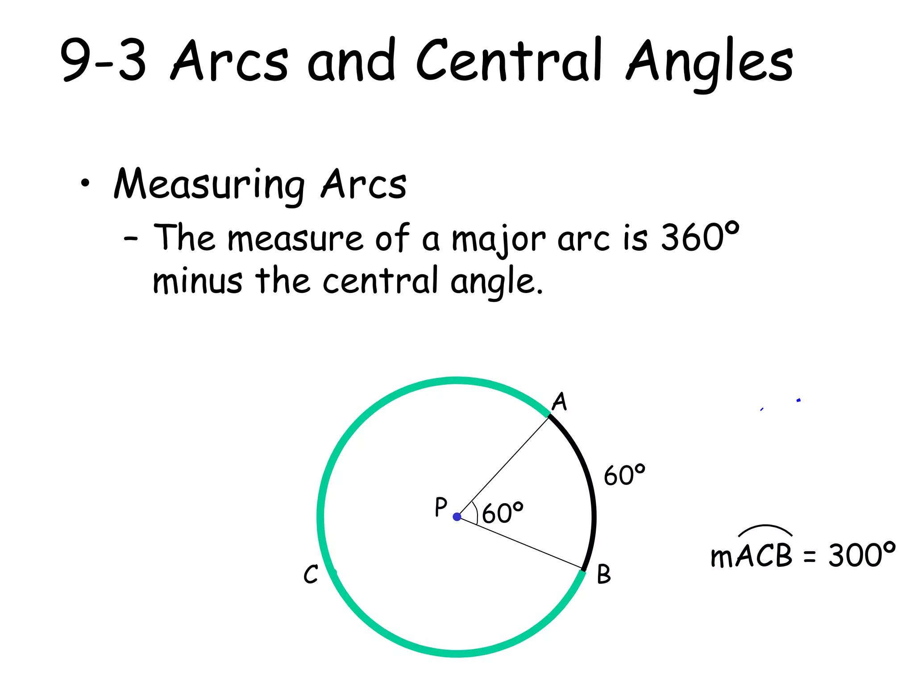
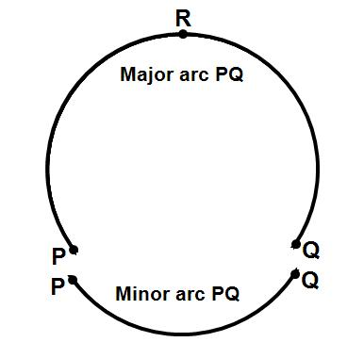
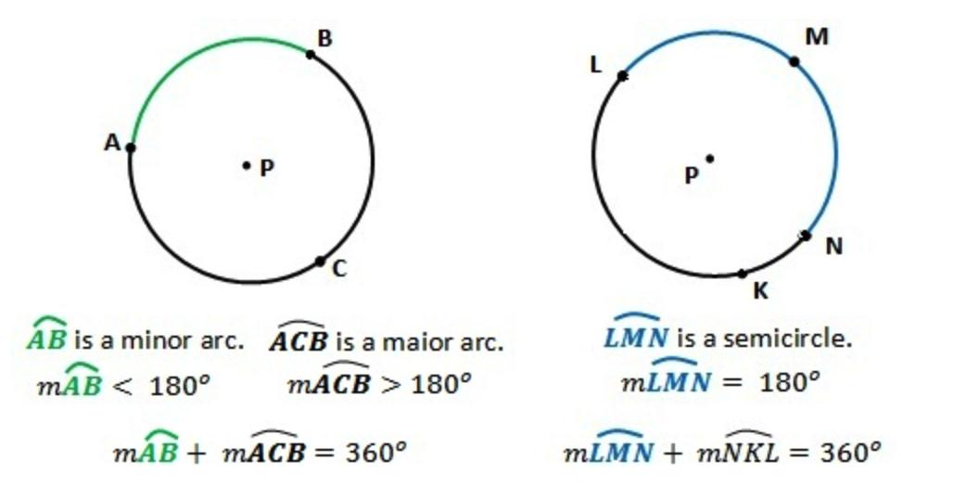

Arc Measure
# Source: AI Source: Provided by: [Data Path: Persons Table -> ID Column: 1, Name_En Column: Motasem Essam] -> From: [ChatGPT] on [7/25/2026]
The measure of an arc is normally expressed in degrees and corresponds to the measure of its central angle.
If $∠AOB$is the central angle subtending arc $\hat{AB}$, then:
$$\boxed{m\left(\hat{AB}\right)=m\left(∠AOB\right)}$$
For the complete circumference:
$$\boxed{{360}^{∘}}$$

Arc Length
# Source: AI Source: Provided by: [Data Path: Persons Table -> ID Column: 1, Name_En Column: Motasem Essam] -> From: [ChatGPT] on [7/25/2026]
The arc length is the actual distance along the curved arc.
For central angle $θ$:
$$\boxed{L=\frac{θ}{{360}^{∘}}\left(2πr\right)}$$
where:
- $L$= arc length
- $θ$= central angle
- $r$= radius
If $θ$is measured in radians:
$$\boxed{L=rθ}$$

Example
# Source: AI Source: Provided by: [Data Path: Persons Table -> ID Column: 1, Name_En Column: Motasem Essam] -> From: [ChatGPT] on [7/25/2026]
A circle has radius:
$$r=10\text{ cm}$$
and an arc subtends a central angle of:
$$θ={60}^{∘}$$
The arc length is:
$$L=\frac{{60}^{∘}}{{360}^{∘}}\left(2π×10\right) \\ L=\frac{10π}{3} \\ \boxed{L≈10.47\text{ cm}}$$

Arc vs Chord
# Source: AI Source: Provided by: [Data Path: Persons Table -> ID Column: 1, Name_En Column: Motasem Essam] -> From: [ChatGPT] on [7/25/2026]
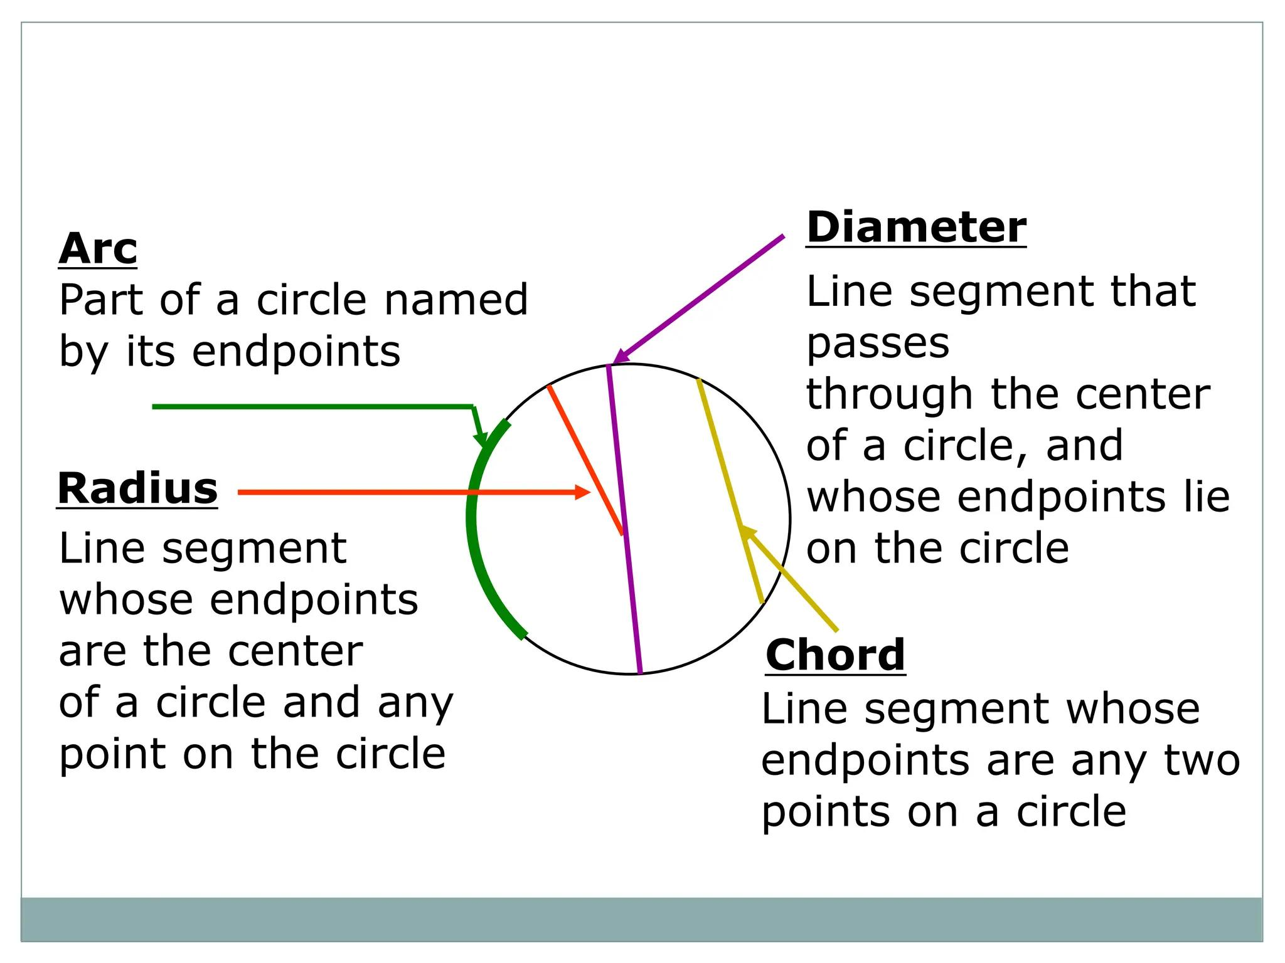
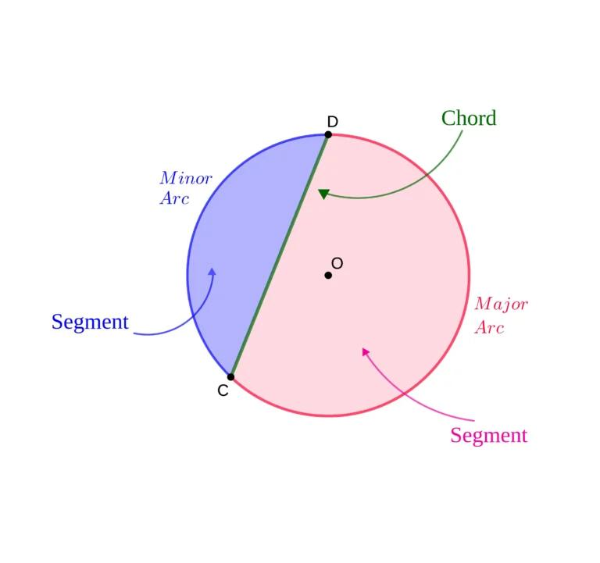
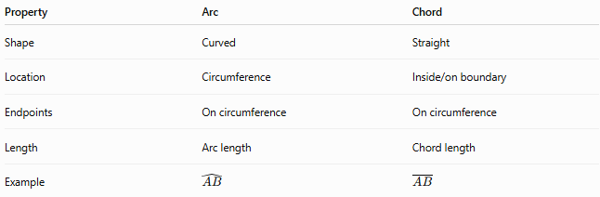
Property | Arc | Chord
Shape | Curved | Straight
Location | Circumference | Inside/on boundary
Endpoints | On circumference | On circumference
Length | Arc length | Chord length
Example | $$\hat{AB}$$ | $$\overset{‾}{AB}$$
The arc and chord can have the same endpoints while representing different geometric objects.

Arc and Central Angle
# Source: AI Source: Provided by: [Data Path: Persons Table -> ID Column: 1, Name_En Column: Motasem Essam] -> From: [ChatGPT] on [7/25/2026]
A central angle determines the corresponding arc.
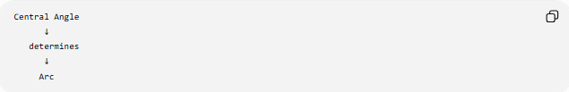
Central Angle
↓
determines
↓
Arc
For example:
$$∠AOB={90}^{∘}$$
corresponds to an arc measuring:
$$\boxed{{90}^{∘}}$$

Arc and Inscribed Angle
# Source: AI Source: Provided by: [Data Path: Persons Table -> ID Column: 1, Name_En Column: Motasem Essam] -> From: [ChatGPT] on [7/25/2026]
An inscribed angle has its vertex on the circumference and intercepts an arc.
Its measure is half the measure of its intercepted arc:
$$\boxed{m\left(∠ACB\right)=\frac{1}{2}m\left(\hat{AB}\right)}$$
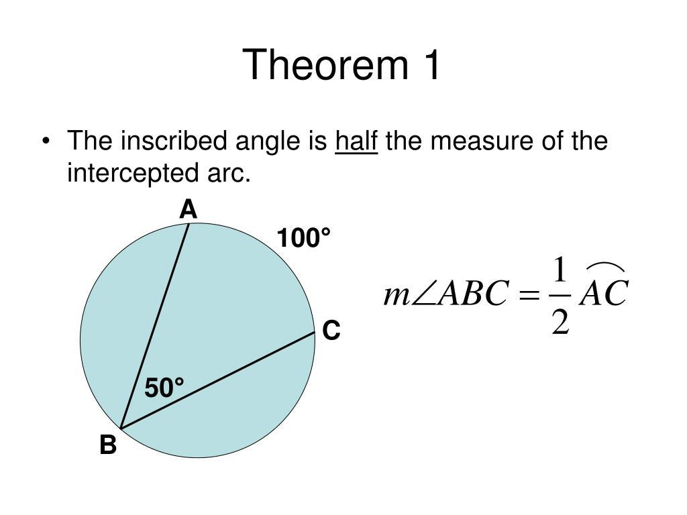
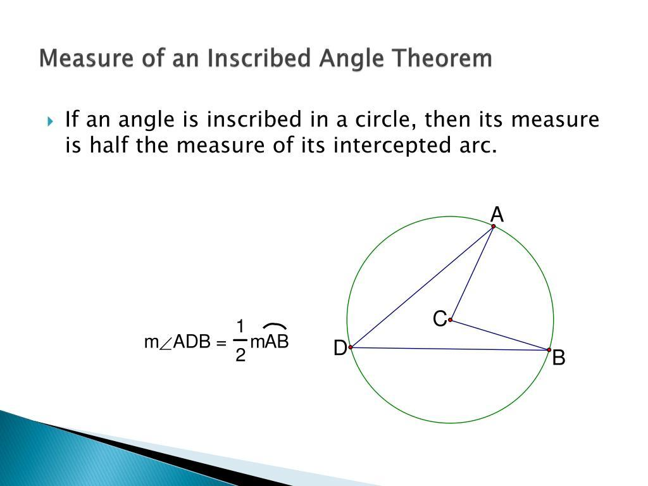
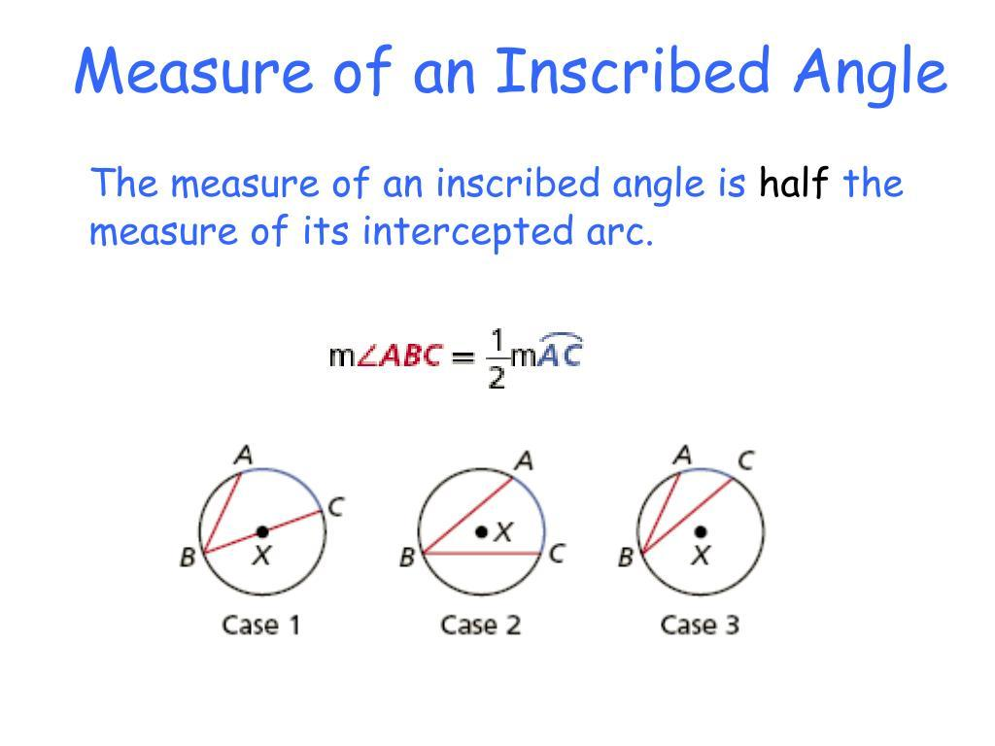
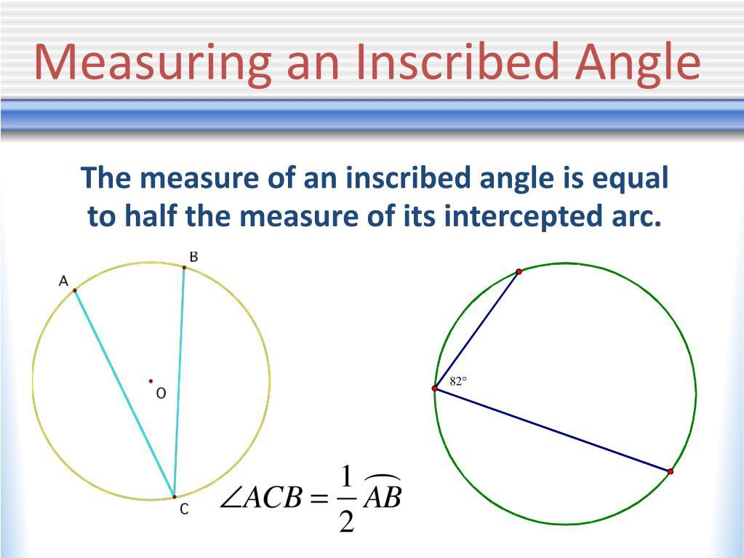

Arc Classification by Measure
# Source: AI Source: Provided by: [Data Path: Persons Table -> ID Column: 1, Name_En Column: Motasem Essam] -> From: [ChatGPT] on [7/25/2026]
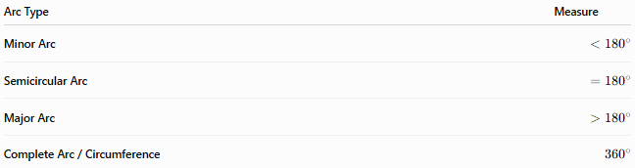
Arc Type | Measure
Minor Arc | $$<{180}^{∘}$$
Semicircular Arc | $$={180}^{∘}$$
Major Arc | $$>{180}^{∘}$$
Complete Arc / Circumference | $${360}^{∘}$$
Arc Notation
For a minor arc, two letters are usually sufficient:
$$\hat{AB}$$
For a major arc, three letters are commonly used to specify which route around the circle is intended:
$$\hat{ACB}$$
where $C$lies on the major arc from $A$to $B$.
A semicircular arc can also be specified with three letters when necessary.

Related Concepts
# Source: AI Source: Provided by: [Data Path: Persons Table -> ID Column: 1, Name_En Column: Motasem Essam] -> From: [ChatGPT] on [7/25/2026]
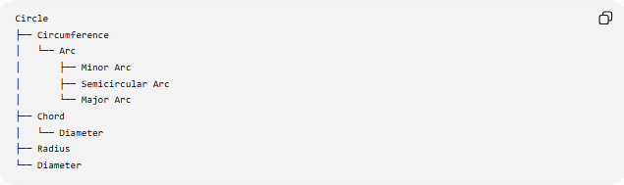
Circle
├── Circumference
│ └── Arc
│ ├── Minor Arc
│ ├── Semicircular Arc
│ └── Major Arc
├── Chord
│ └── Diameter
├── Radius
└── Diameter

Key Points
# Source: AI Source: Provided by: [Data Path: Persons Table -> ID Column: 1, Name_En Column: Motasem Essam] -> From: [ChatGPT] on [7/25/2026]
- An arc is a curved portion of a circle's circumference.
- Its endpoints lie on the circumference.
- Its measure is expressed in degrees.
- A minor arc is less than ${180}^{∘}$.
- A semicircular arc equals ${180}^{∘}$.
- A major arc is greater than ${180}^{∘}$.
- The complete circumference measures ${360}^{∘}$.
- Arc length is a distance measured along the curve.
$$\boxed{L=\frac{θ}{{360}^{∘}}\left(2πr\right)}$$

Conclusion
# Source: AI Source: Provided by: [Data Path: Persons Table -> ID Column: 1, Name_En Column: Motasem Essam] -> From: [ChatGPT] on [7/25/2026]
An arc is a fundamental part of a circle's circumference. Its size can be described by its angular measure or its arc length, and arcs form the basis of important relationships involving central angles, inscribed angles, chords, sectors, and segments.

